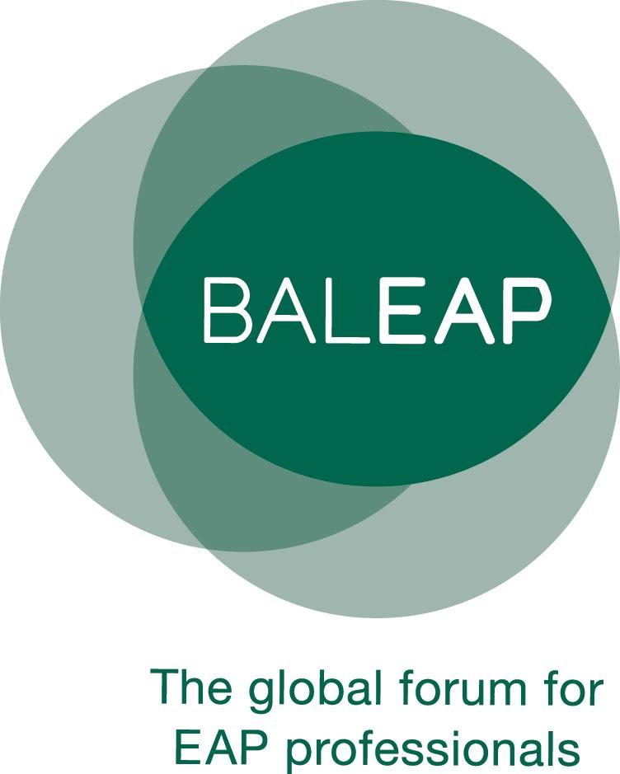

English for Academic Purposes

Masters Dissertation Award

Applications are invited for the annual BALEAP Masters Dissertation Award. The award aims to showcase and encourage Masters dissertations which make a significant contribution to the field of EAP. The dissertations can involve primary research or be literature-based pieces of work.

The competition is open to colleagues who have successfully completed an EAP-related dissertation between September 2023 and October 2024. Only dissertations which have been awarded a distinction, an A grade or a first are eligible.

Please pass on this information to any colleagues and friends who might be interested as the Award is open to all EAP practitioners and researchers worldwide.

The winning writer will be awarded the sum of £250 and a guaranteed presenter’s place and free ticket at a BALEAP event.

The deadline for applications is **Friday 15th November 2024**. The application form is attached to this email.

If you have any questions about the award or application process, please contact Judith at [fundingandawards@baleap.org](mailto:fundingandawards@baleap.org)

**Key dates:**

November 2024 Application forms returned to Funding and Awards Coordinator.

December 2024 Shortlisted applicants contacted and asked to submit their full dissertations to the Funding and Awards Coordinator.

March 2025 Winner notified

April 2025 Winner announced and presented with award at BALEAP Conference