Testing Officer Report AGM April 2024

Summary of Activities from the last 12 Months

April 2023 – April 2024
October 2023 | A working group for the BALEAP Assessment Roadshows have been formed. The group includes Ania Ziomek (BALEAP Testing Officer), Laura Connoly (BALEAP Ordinary Member) and Ania Rolinska.  The group initially met on weekly basis and then fortnightly.
November 2023 | A survey has been produced and emailed to the BALEAP Community for input on the BALEAP Assessment Roadshows’ format & topics.  Majority of respondents were interested in the Roadshows to be online and half-day events.  The list of topics identified and preferences:  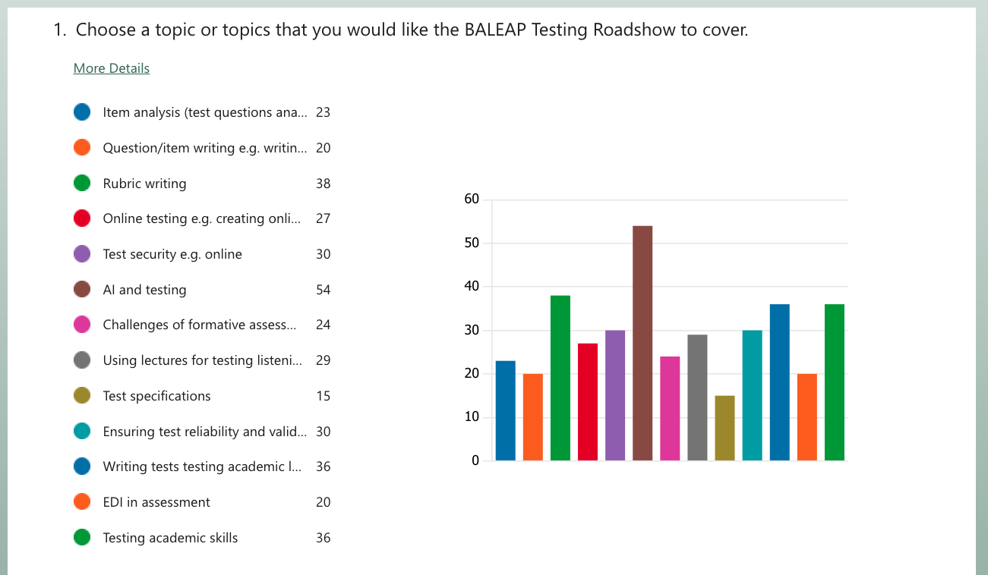
February/March 2024 | Potential speakers for the first Assessment Roadshow have been contacted.
April 2024 | It’s been established that there will be two BALEAP Assessment Roadshows on the topic of AI and Assessment in 2024:  - One will be delivered on the 31st of May by Basim Baig (the Head of Duolingo).  - Second session will be delivered in the second half of July 2024 by Olena Rossi (Independent consultant in language assessment).  We’re in the process of deciding more specific content of the two sessions.
April 2024 | Discussions about BALEAP Testing guidelines initiated.

Report submitted by Ania Ziomek (BALEAP Testing Officer)

