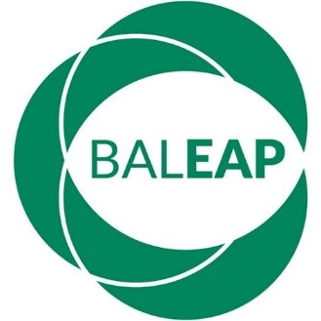 | BAS report for 2024 BALEAP AGM  (Dr Lia Blaj-Ward, BAS Chair, 2022-2025)

- Nine institutions have had courses (re)accredited since the 2023 AGM.
- There have been a number of small changes to the accreditation handbook. The updated version is available on the BALEAP website (https://www.baleap.org/wp-content/uploads/2024/03/BAS-Accreditation-Hbook-v10a.pdf) and a one-page summary of updates can be found at https://www.baleap.org/wp-content/uploads/2024/04/BAS-Handbook-March-2024-summary-of-updates.pdf.
- Two new assessors have joined BAS.
- The annual membership-facing BAS event is taking place on 11 May 2024 at the University of Manchester. The event is titled ‘EAP outside the box’ and is linked to a core principle in the accreditation handbook (contextualisation).
- The winner of the 2023 inaugural Impactful Collaboration award presented a poster at the 16 March 2024 PIM. The winning case study is available on the BALEAP website https://www.baleap.org/wp-content/uploads/2024/03/Case-study-IC-2023-winner-final.pdf.
- The deadline for the 2024 iteration of the Impactful Collaboration award is 31 May 2024 (9am GMT); information about the application process is available in the News section of the BALEAP website (https://www.baleap.org/news/impactful-collaboration-award-2024).
- Please note the accreditation visit fees will increase, from the 2024 AGM onwards, from £175 per assessor per day to £250 per assessor per day, and the report writing fee (one-off) will increase from £200 to £300.
- Succession plans for the next BAS Chair (2025-2028) are in place, with Dr Karin Whiteside taking up the role at the 2025 BALEAP AGM.

