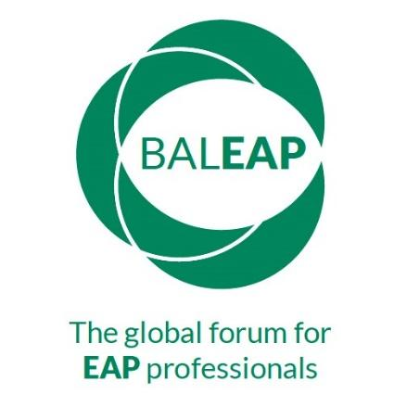 | 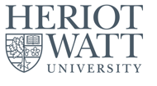

BALEAP online PIM
Multimodality in EAP Contexts
Heriot-Watt University
3rd November 2023

Proposer details
[Title; name; institution, email]
Second speaker (if relevant)
[Title; name; institution, email]
Biodata
30-words
Session Title
Strand in which your project fits | - impact of digital texts on academic and professional communication
 | - multimodal artefacts in EAP (e.g. posters, videos, slides)
 | - multimodal EAP pedagogy (using different modes creatively and reflectively in the classroom)
 | - multimodal approaches and widening participation (using visuals, video, different types of text to help students with diverse needs engage with learning outcomes).
Type of Session: | - Online live presentation (15-20 mins + 10-15 mins questions)
 | - Recorded presentation (15-20 mins + asynchronous questions
 | - Recorded presentation (15 mins + online live Q&A)
 | - Poster presentation
 | - Other
Abstract for programme
(max. 250 words)
Consent  Do you agree to publication of materials on the BALEAP website | Slides yes ___ no ____  Audio recording yes ___ no ____
Consent  Do you agree to your live presentation being recorded? | Yes/No

Please return to: MultimodalityPIM@hw.ac.uk

