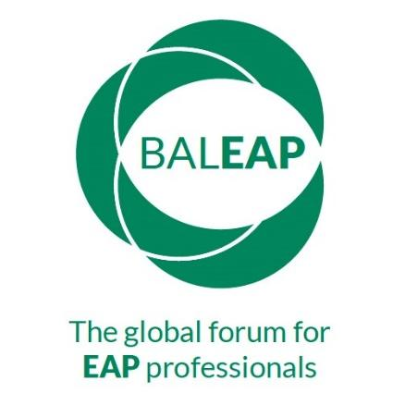
BALEAP PIM
Intercultural Communication and English for Academic Purposes
Language Centre, University of Leeds, Leeds LS2 9JT
Friday 17th June 2022
Proposer details
[Title; name; institution, location if applicable; email]
Biodata
30-words
Session Title
How the proposal contributes to the theme of the PIM (max. 60 words)
Type of Session: | - Face-to-Face Presentation (20-30 mins & 10 mins Q&A)  - Recorded asynchronous presentation (25 mins)  - Workshop (30 mins & 10 min break)  - Poster presentation  - Symposium/Round table SiG discussion (2 x 40 mins; 80 mins)  Other | ___  ___  ___  ___  ___  (Please specify)
Summary for programme
(max. 250 words)
Technical Requirements | Data projector
Consent  Do you agree to publication of materials on the BALEAP website and / or the University of Leeds CELT* website | Slides yes ___ no ____  Handouts yes ___ no ____  Video/ Audio recording yes ___ no ____
Consent  Do you agree to your live (face-to-face or virtual) presentation being recorded? | Yes/No
Consent  Do you agree to your recorded presentation or workshop to be shared on the BALEAP website and / or the University of Leeds CELT website? | Yes/No

The BALEAP website is https://www.baleap.org/
CELT is the Centre for Excellence in Language Teaching, University of Leeds: https://celt.leeds.ac.uk/

