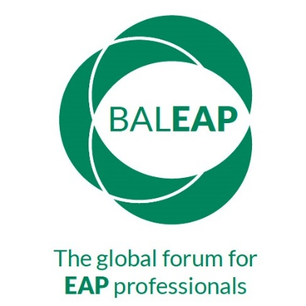 | BALEAP 50th Anniversary Event  2nd April 2022

Lightning Talks Proposal Form
Theme: The Next 50 Years in EAP
Please complete this form and email it to events@baleap.org by Monday 28th February.
Proposer details
[Title; name; institution; location; contact email]
30-word biodata
Session Title
How the proposal contributes to the theme of ‘The Next 50 Years in EAP’ max. 60 words
Type of Session:
Face-to-face (f2f) presentation; video followed by f2f Q&A; video and asynchronous Q&A
Summary for programme
max. 150 words
Technical Requirements
Do you agree to the publication of materials on BALEAP website | Slides yes ___ no ____  Video recording yes ___ no ____

