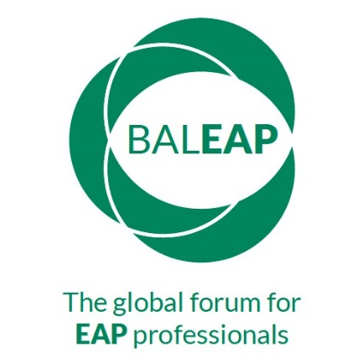

BALEAP PIM
The Future of EAP: Adapt or Die?
English Language Centre
Goldsmiths, University of London, New Cross, London SE14 6NW
Saturday 9 November 2019
Proposer details
[Title; name; institution, if applicable; email]
30-word biodata
Session Title
How the proposal contributes to the theme of the PIM [max. 60 words]
Type of Session  [Presentation/Workshop] | Presentation (20 mins & 10 mins questions)  Workshop (30 mins or 60 mins) | ___  ___ (30) ___ (60)  (please indicate)
Summary for programme
[max. 250 words]
Technical Requirements
Publication of materials on BALEAP website | Slides yes ___ no ____  Handouts yes ___ no ____

