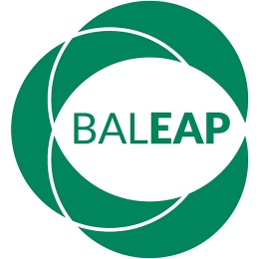  www.baleap.org | BALEAP Collaborative Practice Funding  Sharing existing practice to facilitate further development  Initial expression of interest

Please read the funding information sheet carefully before submitting the application. If you have any questions about this form please email treasurer@baleap.org.

Case study title

Case study authors
For each co-author, please indicate title, name, role, institutional affiliation, email address and telephone number, whether member of BALEAP or another organisation.

Case study outline (max. two sides of an A4 sheet)
Please include a description of the experience, the rationale for setting it up, the impact it had on participants, main learning points for the team that designed and delivered the experience and a closing commentary on how others could benefit from the case study. The outline can be in note form rather than full text throughout.

Event for which funding is requested
Please include a link to the event’s webpage and a brief description of why you have chosen this particular event. The panel will be looking for evidence that applicants have carefully considered how attendance sits within their wider professional development plan and why the audience at the event will benefit from the case study being shared.

Institutional endorsement
Please ensure you have institutional support and include here title, name, role, institutional affiliation, relationship with applicant, email address and telephone number of the person who is endorsing the application. They will be contacted directly to confirm their support if your application is successful.

Deadline for submission
Please submit the completed application by 9am on 30 April 2019 to treasurer@baleap.org.

