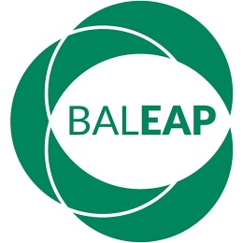  www.baleap.org | BALEAP Collaborative Practice Funding  Pilot projects  Application form

Please read the funding information sheet carefully before submitting the application. If you have any questions about this form please email treasurer@baleap.org.

Project title

Amount applied for
£1,500
£500

Co-applicants
For each co-applicant, please indicate title, name, role, institutional affiliation, email address and telephone number, whether member of BALEAP or another organisation.

Project abstract (max. 100 words)

Rationale for setting up the project (max. 250 words)
Please indicate in what way the project is innovative in the context in which it will be delivered and how it responds to an identified need.

Workplan with actions timelines and information about participants and facilitators (max. two sides of an A4 sheet)
The projects are expected to take place between Aug 2019 and 31 July 2020.

Impact evaluation and insight dissemination plan (max. two sides of an A4 sheet)
Please indicate how you are planning to evaluate the project (e.g., what you are hoping to achieve and how will you know this has happened); any expected follow-on activity to ensure longer term value; and how findings from your project can be further disseminated across the sector.

Budget breakdown
Please note the funding can be used to cover travel expenses for participants, travel and accommodation for speakers if applicable, or catering at an event. Some costs associated with producing an output that can be disseminated outside the institution hosting the project may be covered subject to prior agreement. Funding is not available for hardware or staff salaries.

Institutional endorsement
Please ensure you have institutional support and include here title, name, role, institutional affiliation, relationship with applicant, email address and telephone number of the person who is endorsing the application. They will be contacted directly to confirm their support if your application is successful.

Deadline for submission
Please submit the completed application by 9am on 31 May 2019 to treasurer@baleap.org.

