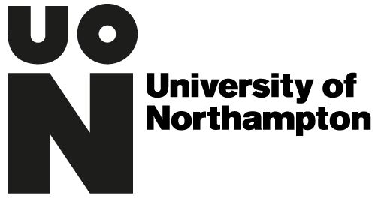
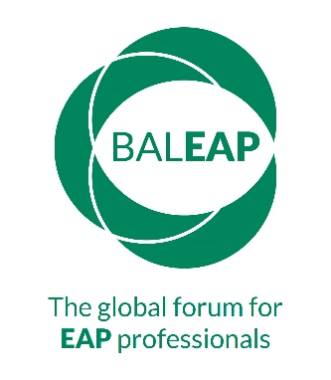
BALEAP PIM Saturday 22nd June 2019

Knowledge in EAP - call for host proposals

University of Northampton, Waterside,
Northampton, NN1 5PH

The structure of this PIM is quite different. Using the world café format, we aim to generate discussion and enable contributions from the wider audience enabling us all to gather a richer snapshot of the EAP community’s beliefs and experiences. The event will include a series of concurrent world café sessions and therefore we are asking for proposals to host these sessions. The aim is that hosts provide hospitable spaces for the community to explore questions that matter to us, enabling the group to ‘harvest’ the insights with the purpose of sharing this insight more widely.

The world café process involves the following stages:

- Welcome: the host sets the context of the room, introducing the room to an aspect of knowledge within EAP that the host feels passionate about and/or has researched [6 mins max]
- The host facilitates the group’s exploration of this context through up to four related questions posted on four separate tables in the ‘café’. Questions should foster discussion and deep reflection on where we are at as a discipline and how we can move forward; possibly exploring where we are, where we should be going, the knowledge we have, and the knowledge we need, within the realms of the café’s focus.
- The café visitors spend a set time at each of the four tables in the room (groups can change personnel, but everyone should visit the four tables within the session)
- Ideas are left on the table: written or drawn on the table cloths
- Host leads a group ‘harvest’ of ideas
- The host collates café input

[Each session will last between 60-90 minutes]

Although this is a one-day event, it is hoped that it will be a catalyst for taking EAP in new directions, with long-lasting impacts. The intention is that there are tangible outputs from the day to be published and made freely available to the global EAP community. To this end, we will be inviting hosts to submit a write-up of the café for publication online [circa 2,000 words].

We would also welcome poster presentations from current doctoral researchers and practitioners.

Please indicate which format you are proposing:
World café host ☐ | Poster ☐
Area of knowledge to be explored in the café and rationale [max. 200 words]:  Proposed questions:  1.  2.  3.  4. | Content summary [max. 200 words]:

How the proposal/poster contributes to the theme of the PIM [max. 60 words]
Name: | Email:
Affiliated institution:

Biodata: [max. 80 words]

Please submit proposal forms to baleap@northampton.ac.uk by midnight Sunday 17th March 2019

