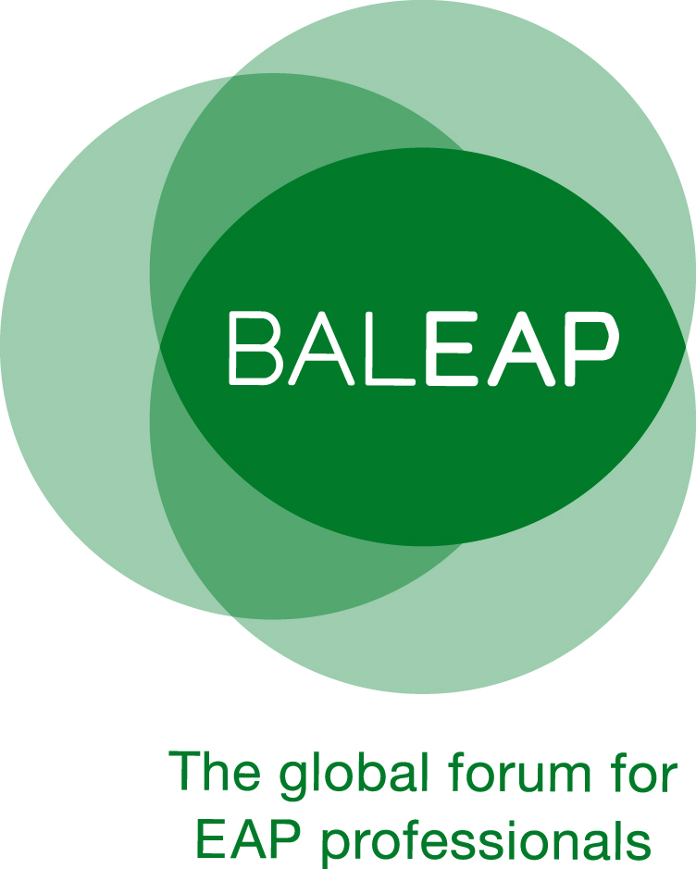

BALEAP PIM
Assessing the assessors:
reviewing assessment practices in (and beyond) EAP

Birmingham International Academy, University of Birmingham, Edgbaston
Birmingham B15 2TT
Saturday 23 February, 2019
Proposer details
[Title; name; address; email; phone; 30-word biodata]
Session Title
How the proposal contributes to the theme of the PIM [max. 60 words]
Type of Session | - *Lightning Presentation (10mins + panel questions)  - Standard Presentation (20 mins & 10 mins questions)  - Workshop (40 mins)  - Poster presentation  - Other | ___  ___  ___  ___  ___  (please indicate)
Summary

[max. 250 words]
Technical Requirements | e.g. Data projector
* We envisage 4 x 10 minute presentations per session with questions fielded to the presenters by a chair once all presentations are complete.
Please submit proposal forms to biaconferences@contacts.bham.ac.uk

