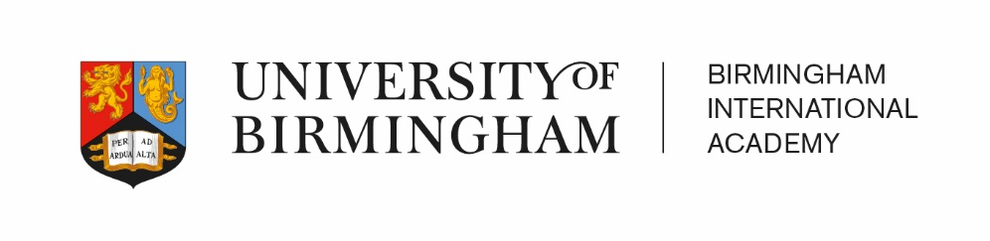
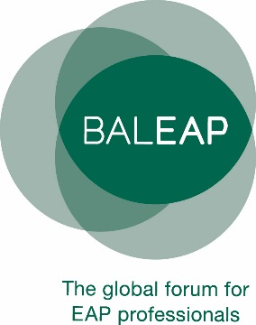

BALEAP Professional Issues Meeting (PIM)

Assessing the assessors:
reviewing assessment practices in (and beyond) EAP

Saturday 23 February, 2019
Edgbaston Park Hotel and Conference Centre (Building G23 – Green Zone),
53 Edgbaston Park Road, Birmingham B15 2RS

Travel and accommodation information
Travel
The university website provides details on travel routes to the university. Trains run every 10 minutes from Birmingham New Street to the University train station on the Central City line. The conference will take place at Edgbaston Park Hotel and Conference Centre. This is in the green zone of the campus and is building G23 on the Edgbaston campus map. The hotel entrance is on Edgbaston Park Road. It is around a 10-15 minute walk from University train station. There is no taxi rank at this station. Castle Cars and TOA taxis are both reputable local taxi companies.
Campus Parking
Parking on campus is available at the following locations:
- Outside Edgbaston Park Hotel and Conference Centre
- Outside Priorsfield, Building G18 – Green Zone, (access via Edgbaston Park Road, opposite the conference venue)
- North East Multi Storey car park (access via Pritchatts Road - Sat Nav Postcode B15 2SA).

Please note that locations 1 and 2 have limited parking availability. Also, options 2 and 3 are about a 3-minute walk away from the conference venue.

Parking charges are applicable Mon-Fri 08:00 – 18:00 (excluding bank holidays). However, if you are staying at Edgbaston Park Hotel and arrive on Friday 22 February, complimentary parking – in location 1 or 3 - is included in your stay.

Parking at all of the above locations is free at the weekend.

On Campus Accommodation
We have secured accommodation at Edgbaston Park Hotel and Conference Centre at favourable rates.

To book accommodation at Edgbaston Park Hotel you must either send an email to Lucy Woods or Matthew Arnott at reservations@edgbastonparkhotel.com or telephone Lucy at +44(121) 414 9780 or Matthew at +44(121) 414 9779.

In either case, please quote the booking reference code of: BALEAP19. This will enable you to book a Double Room at the rate of £113 B&B (Single occupancy) or an Executive Room at the rate of £158.00 B&B (Single occupancy).

Please note that any bedrooms not reserved by 12/01/2019 will be released back on the system for general resale to the public. Guests will not be able to book using the code after this date but may be able to book at the standard rate if there is availability.

In addition, Lucas House Hotel is another University of Birmingham accommodation option. It is located opposite the conference venue.

Alternative accommodation
If you would prefer to find accommodation off campus, the Visit Birmingham website has details of places to stay as well as general information about things to do in the local area.

