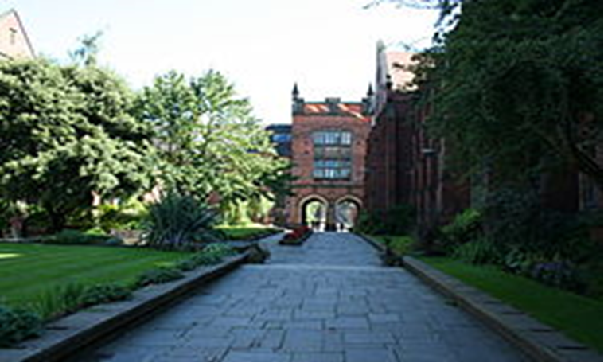  The Old Quad |   Robinson Library
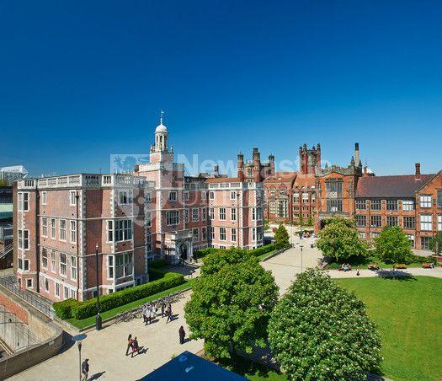  King’s Walk | 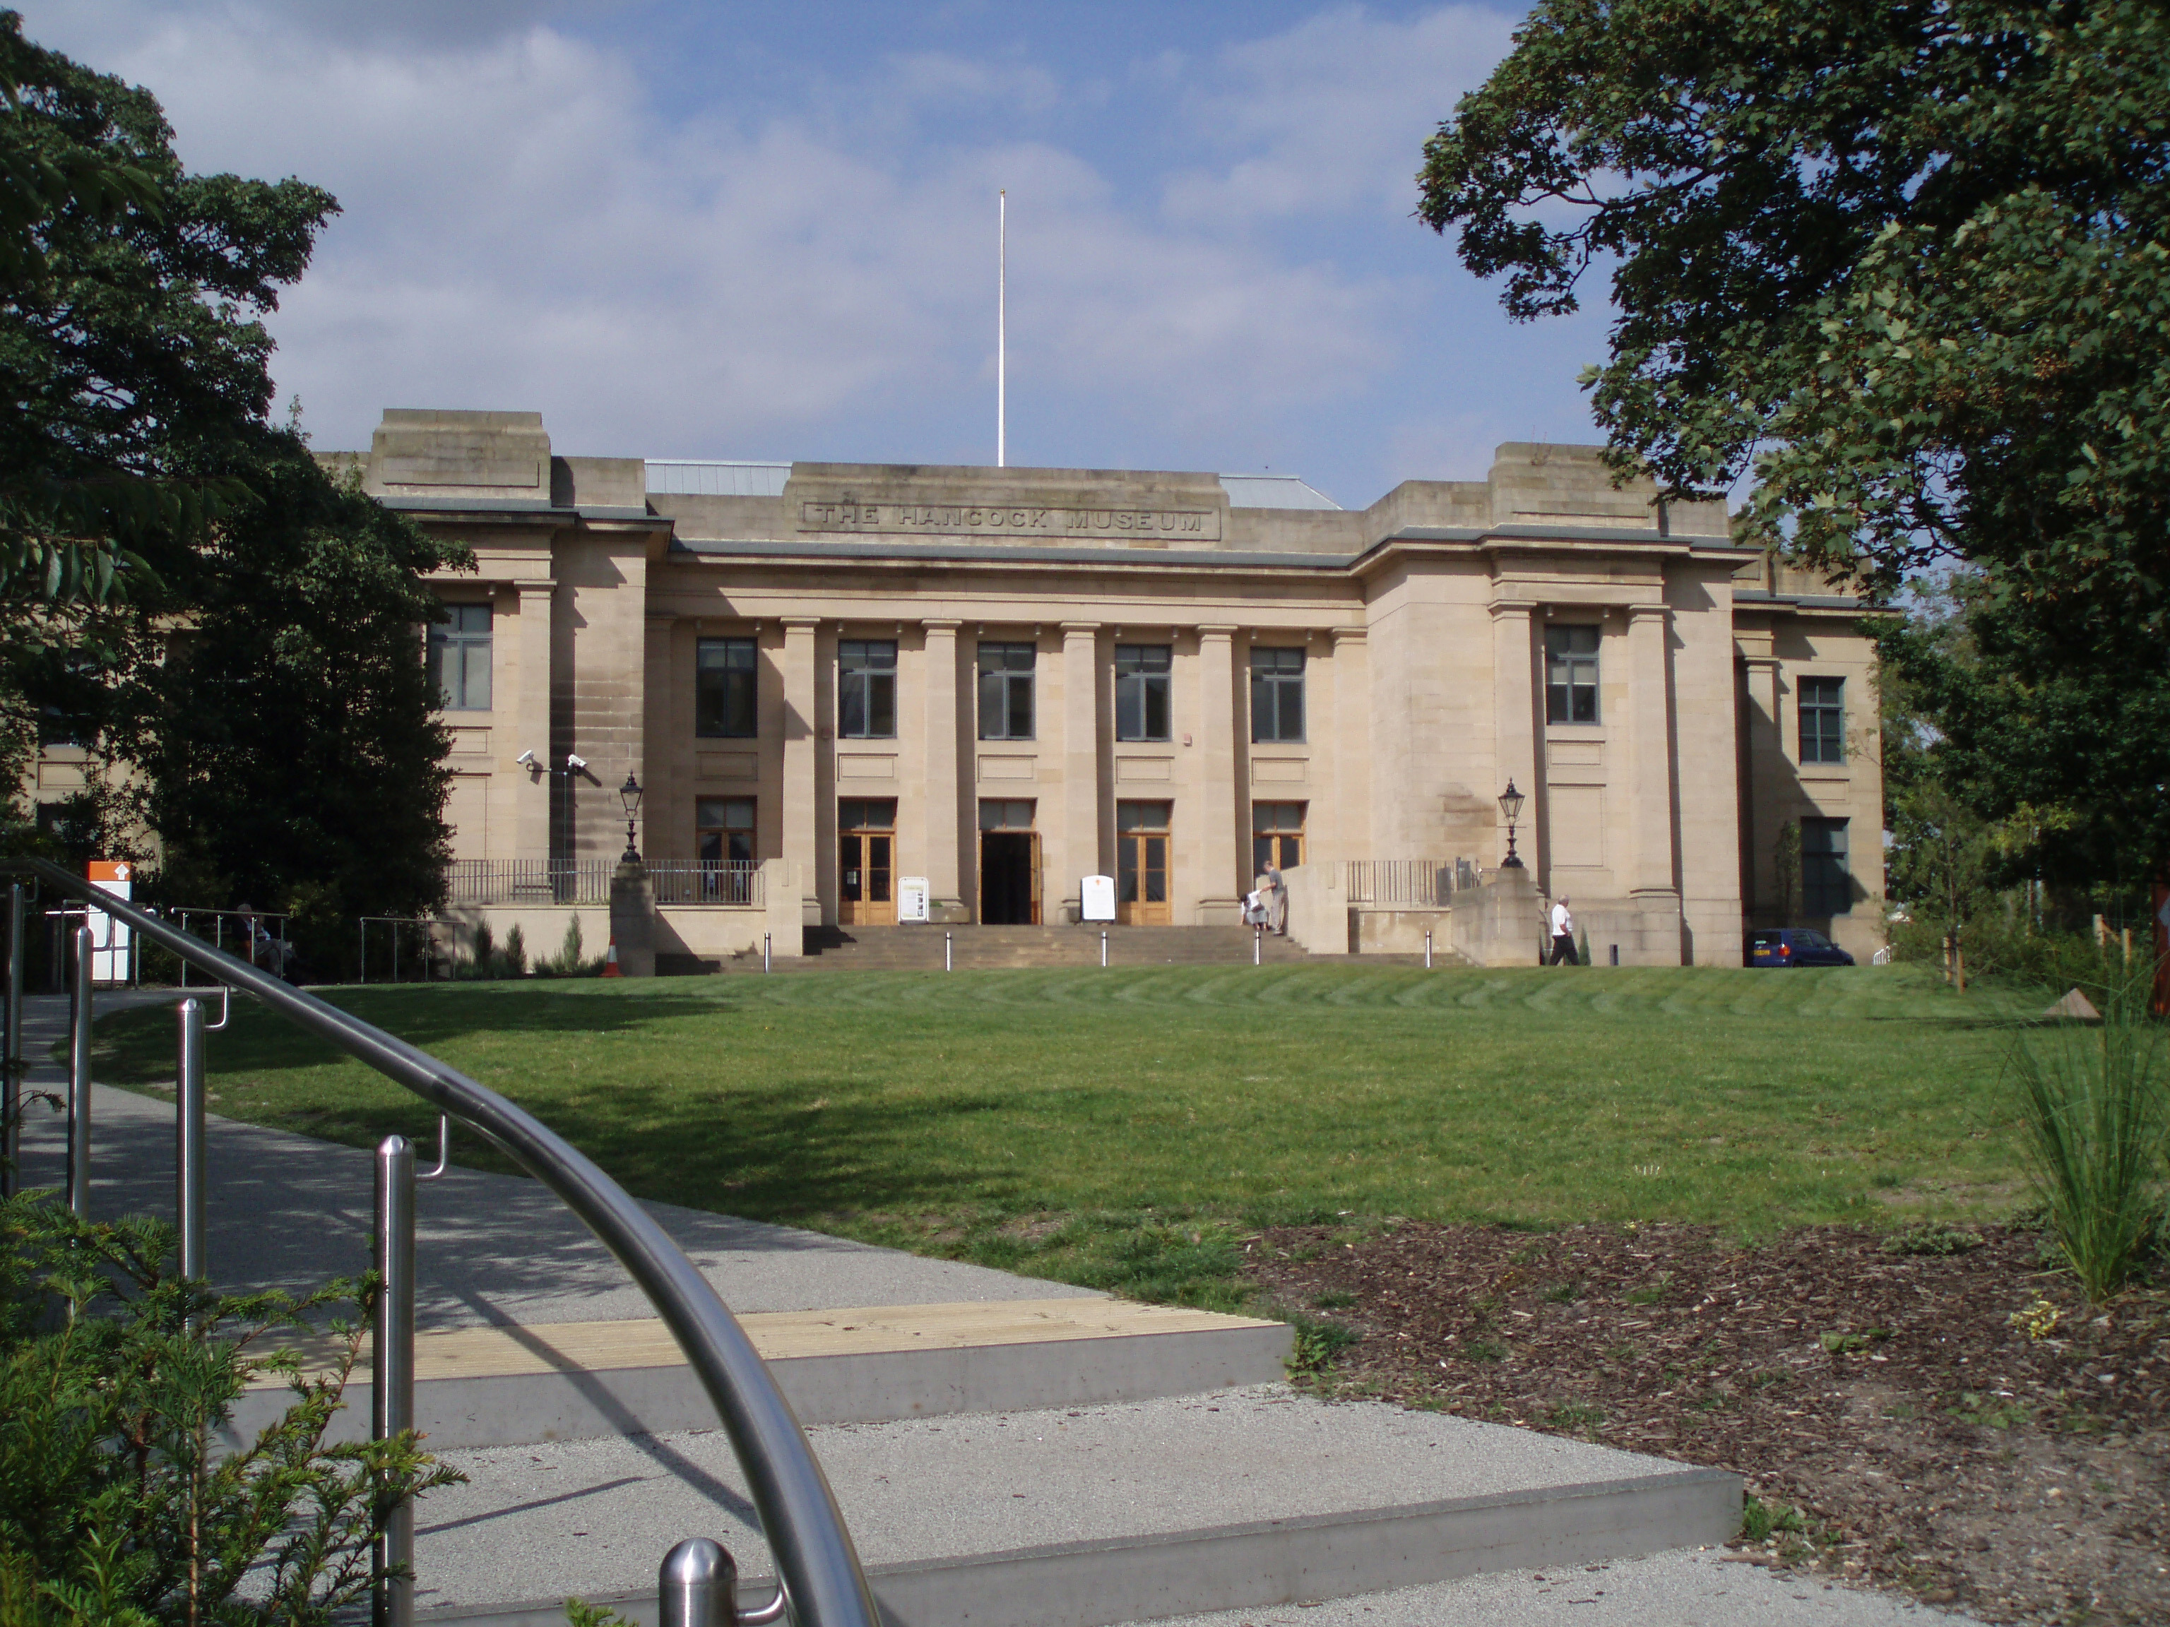  The Hancock Museum

EAP PATHWAY PROGRAMMES SPEAKING ASSESSMENT
You and your partners will work on a task that involves reaching an agreement. The task will take approximately 30 minutes to complete, including 8 minutes preparation.

Test 1: Choose the best location on campus for the Wishbone House sitooterie

SITUATION

This year Newcastle University School of Architecture has been offered one of the exhibited Belsay Hall sitooteries, the Wishbone House, to place on campus for students to use. Four locations have been singled out and now the panel must choose the most suitable one for this intervention.

About the Wishbone House sitooterie:
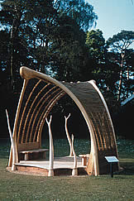 | Definition: ‘Sitooterie’ is a Scottish colloquial term, meaning a summerhouse or gazebo; generally, a place to sit and contemplate.  The ‘Wishbone House’ is a portable pavilion constructed with seven oak arches supporting a willow wall above an asymmetrical elm wood floor. Inside there are two benches for people to sit on.

INDIVIDUAL PREPARATION (8 MINS)

Choose the best location from the four sites around campus that you think is most suitable. You may write down some notes. You must not discuss your ideas at this time. Think about the following points:
- Suitability: Is the location appropriate for the sitooterie?
- Purpose: Who will use the sitooterie and for what purpose? Does it suit these people and this purpose?
- Aesthetics/materials: Where is the sitooterie likely to blend into its surroundings?
- Maintenance: How much upkeep does the sitooterie need?
- Can you think of any other points which may interest your group?

GROUP WORK (12-15 MINS)

Now tell your partners which location you have chosen and listen to their views. Remember that the purpose of this task is to come to an agreement. Try to persuade your partners to agree with you, but be prepared to compromise.

