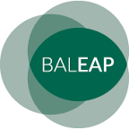
Professional Issues Meeting at Nottingham Trent University
Intercultural Communication and EAP
BALEAP & BAAL Intercultural Communication SIG
18th November 2017
https://www.baleap.org/event/intercultural-communication
In today’s globalised, yet increasingly polarised world, communication skills, cultural knowledge, cultural sensitivity and open-mindedness towards others would seem to be more important than ever. The task of helping all students develop this core intercultural competence is surely one to be shared by all educators, but as EAP teachers and language professionals we are perhaps better placed than many to address it, to increase awareness of its importance and share our best practice with colleagues in other disciplines.
We would warmly welcome proposals for papers on any aspect of this broad theme. For example, papers could focus on, but not be limited to, the following topics:
In the classroom
This strand hopes to answer questions such as: Should we explicitly teach/attempt to facilitate intercultural communication in the EAP classroom? If so, how do we do it, and can/should it be assessed?
On campus
This strand hopes to answer questions such as: What is our role in preparing students for and helping them navigate campus life and an internationalised curriculum?
Professional development
This strand hopes to answer questions such as: What intercultural competencies do we need to develop as teachers? How can we help develop these across our institutions?
Wider Social Responsibility and Social Justice
This strand hopes to answer questions such as: What role does the field of language and intercultural communication have in, and in what ways can it contribute to, addressing the recent worldwide political events that have challenged liberal, critical and ethical discourses on issues such as diversity, intercultural relations and social justice.
The theme could apply equally to pre-sessional or in-sessional EAP, and to undergraduate, post-graduate and foundation programme students in the UK and around the world.
Call for papers: Abstracts (300 words) should be sent to ntupim@ntu.ac.uk by 10/09/2017 using the proposal form (see below).
Keynote Speaker: Professor Adrian Holliday of Canterbury Christchurch University
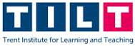
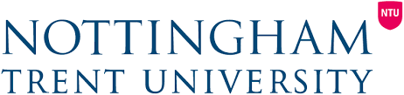
In the meantime please don’t hesitate to contact the PIM chair, Martin Seviour, with any queries, comments or suggestions using the conference email address (given above).

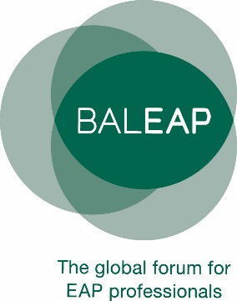
Professional Issues Meeting - Nottingham Trent University
BALEAP & BAAL Intercultural Communication SIG Intercultural Communication and EAP
18th November 2017

Proposer details
name
email
30-word biodata
Title
How the proposed session contributes to the theme of the PIM [max. 60 words]
Type of Session | - Presentation/workshop (20 mins & 10 mins Q&A) | ☐
 | - Poster presentation | ☐
Summary
[max. 300 words]
Requirements

