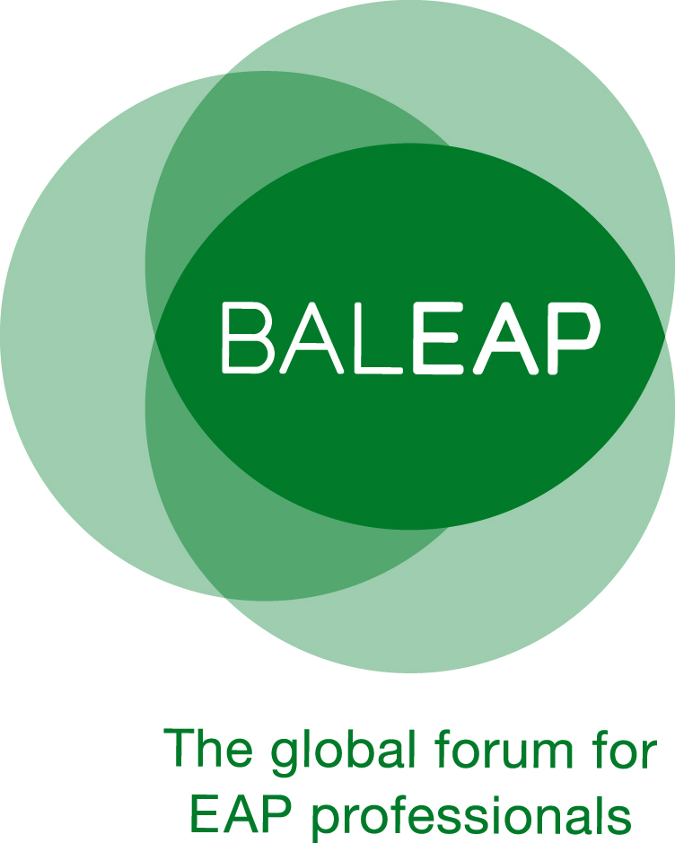 | English for Academic Purposes  2018* Masters Dissertation Award  APPLICATION FORM
* The 2018 award covers dissertations for which grades were officially released between September, 2017 and the cut-off point for award submissions (Monday, November 26th, 2018)

Applicant information
Family name
First name
Email address
Phone number
Correspondence address

Dissertation information
Dissertation title
Degree (to be) awarded | (Delete as appropriate: MA/MSc/MRes/MPhil.)
Awarding institution
Date of results release | (Indicate the date on the official document stating the mark for your dissertation.)
Result | (Indicate mark and/or classification and attach scanned copy of result.)
Dissertation abstract

Additional information to be provided by the applicant
In no more than 750 words, please explain:

- your methodological approach, data collection methods and sample , providing comprehensive information about the range and type of your data (this should include additional detail to the abstract)
- why you consider the work to be a key contribution to current knowledge in the EAP field,
- in what ways the BALEAP community can make use of insights from the dissertation (e.g. teaching, materials development, course design, staff development, quality assurance procedures, programme management, policy development, future research etc).

Please note:
Completed application forms should be emailed to research@baleap.org by Monday, November 26th, 2018. Shortlisted candidates will be invited to submit an electronic copy of their dissertation in January 2019 and the winner will be announced in March 2019.

