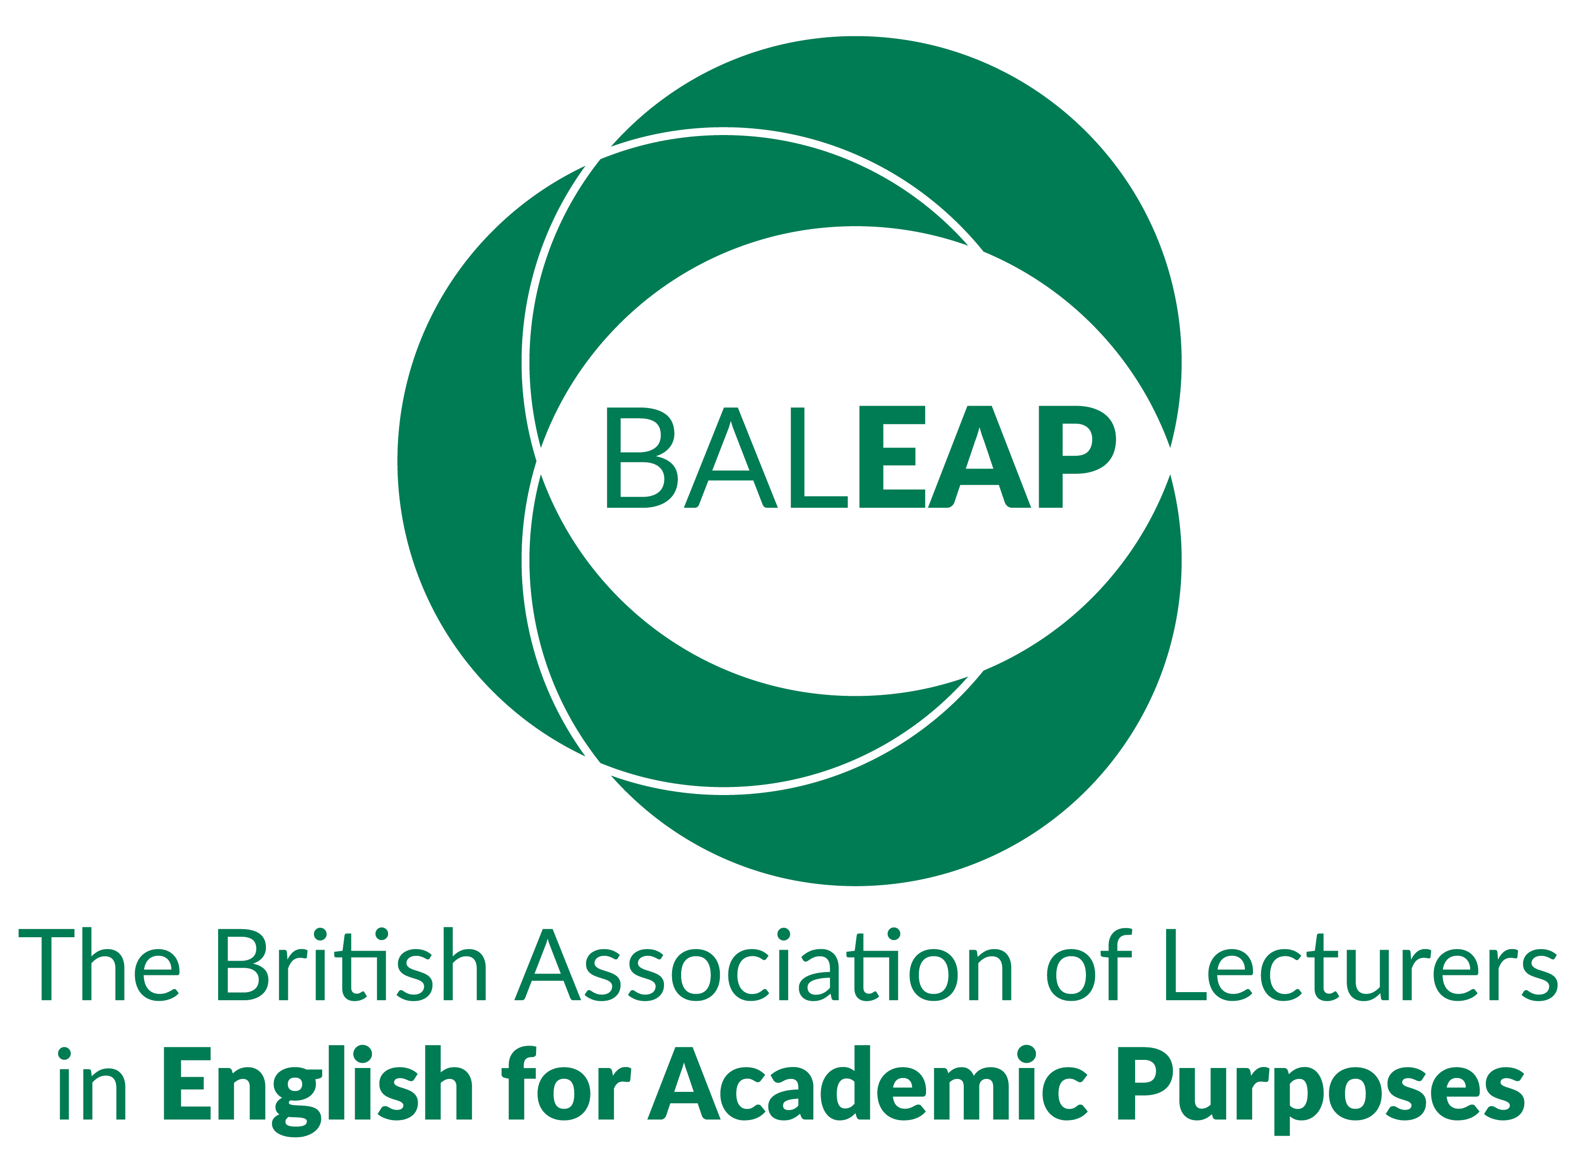

BALEAP Pathways to Impact:

Case Study Grants

Call for Expressions of Interest (EOI)
BALEAP invites Expressions of Interest for the Pathways to Impact Funding Stream, supporting members to develop case studies demonstrating the impact of English for Academic Purposes (EAP) on student success and institutional outcomes.
This scheme provides funding, and sector visibility for practitioner-led research that evidences the value and influence of EAP in higher education.

Funding Available

Document-based or secondary case studies
- Using existing institutional data or documentation
- Up to £750
- 12-month timeframe

Primary research case studies
- Interviews, surveys, observations, or mixed methods
- Up to £1,500
- 18-month timeframe
All projects must show clear and demonstrable EAP impact.

Eligibility
- Open to all BALEAP members (individual or institutional) at any career stage
- Members without institutional affiliation are encouraged to collaborate with colleagues in partner institutions to help ensure access to data, ethics procedures, and other essential resources.
Please note that BALEAP particularly welcomes applications involving fixed term, casualised, unwaged, or otherwise precariously employed colleagues as co-applicants, named researchers, or collaborators alongside staff on permanent contracts

Award Holder Requirements
All funded projects must:
- Submit a 500-word interim report at the project midpoint.
- Submit a 1,000-word final report within one month of completion.
- Produce a written case study suitable for publication in the BALEAP Journal of Research and Practice (special issue planned).
- Share outcomes at a BALEAP conference, PIM, or webinar.
- Acknowledge BALEAP funding in all outputs.
- Obtain institutional ethical approval before collecting data (if applicable).

Assessment Criteria
EOIs will be evaluated on:
- Relevance to demonstrating EAP impact
- Clarity and feasibility of proposed methods
- Contribution to EAP knowledge and practice
- Value for money
- Ethics, inclusivity, and diversity considerations
Please note that revisions may be requested, and shortlisted candidates will be invited to an interview.

Timeline
Stage | Date
Call opens | January 2026
Deadline for EOIs | March 2026
Shortlisting | April 2026
Interviews | July 2026
Decisions issued | August 2026
Awards announced | September 2026
Projects begin | October 2026

How to Apply
To apply, please complete and return the application form to:
📧 research@baleap.org - no later than Friday 13th March at 5pm.

Enquiries
For informal discussions or queries, contact: BALEAP Research & Publications Officer at research@baleap.org

