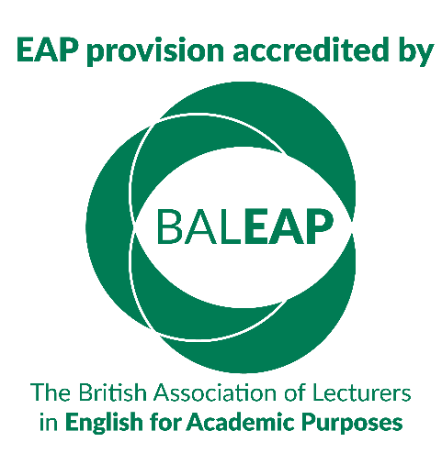

BALEAP ACCREDITATION VISIT FEEDBACK

Institution name:
Visit dates:
1. Which are the three most important benefits to you from the (re)accreditation experience
overall?

2. Were you given sufficient opportunities to provide relevant evidence so that assessors could make a fully informed decision about your provision? If not, please let us know how we could have improved this aspect of the accreditation.

3. Did you experience any challenges while preparing for the visit, during the visit or during
post-visit arrangements that would be useful for the course accreditation scheme to be
aware of? Please provide details to help us enhance the scheme and your experience of it.

4. With specific reference to the accreditation handbook, is there anything we can make
clearer to support applicants for (re)accreditation?

5. Other than the two-year formal interim report stage, is there anything else you would like
the scheme to put in place to support you on your quality enhancement journey?

